Pre-Lab Readings

Background Information

An embedded system, as opposed to a general-purpose computer, is a special system in which the computer is completely encapsulated by or dedicated to the device and its controls. Unlike a general-purpose computer, such as a personal computer, an embedded system performs one or a few predefined tasks, usually with very specific requirements. Since the system is dedicated to specific tasks, design engineers can optimize it, reducing the size and cost of the product. Embedded systems are often mass-produced, benefiting from economies of scale.

Usually intermediate developers face the following issues while working on embedded platforms:
- Finding affordable hardware platform
- Finding easy to follow and organized documentation
- Finding open source and customizable compilers and assemblers
- Finding a simple and affordable Integrated Development Environment (IDE)
- Difficulties with testing, transferring and debugging code on target platform
- Finding simple and understandable examples for hardware modules
- Need of electrical knowledge and general understanding of target platform
- Need of high tech and expensive equipment (i.e. precision oscilloscopes and logic analyzers)
- Finding simple and affordable embedded operating system

Freescale Semiconductor Inc.

Freescale Semiconductor Inc. is a semiconductor manufacturer created by the divestiture of the Semiconductor Products Sector of Motorola in 2004. Freescale focuses on the automotive, embedded and communications markets for their semiconductor products. Freescale is among the worldwide top 50 Semiconductor sales leaders.

The 68HC12 (6812 or HC12 for short) is a 16bit micro-controller family from Freescale Semiconductor. Originally introduced in 1994, the architecture is an enhancement of the previous Freescale 68HC11. Programs written for the HC11 are usually compatible with the HC12, which has a few extra instructions. The first 68HC12 derivatives had a maximum bus speed of 8 MHz and flash memory sizes up to 128 KB.

Like the 68HC11, the 68HC12 has two 8 bit accumulators A and B (sometimes referred to as a single 16 bit register D), also two 16bit registers X and Y, a 16 bit program counter, a 16bit stack pointer and an 8 bit Condition Code Register.

Motorola has launched the new HCS12 (also known as MC9S12) product line in 2000. The bus speed was improved up to 25MHz and flash sizes up to 512 KB. The MC9S12NE64 was introduced by Freescale in September 2004, claiming to be the “industry's first single-chip fast-Ethernet Flash microcontroller”. It features a 25 MHz HCS12 CPU, 64 KB of FLASH EEPROM, 8 KB of RAM, and an Ethernet 10/100 Mbit/s controller. Since the HCS12 was a direct upgrade to the existing HC12 family, most of the links and information provided here are suitable for both lines.

Latest addition in 2004 was the advanced HCS12X, providing even more features, including the XGATE DMA co-processor. HCS12X is fully backward compatible with HCS12 CPU. The S12X family utilizes the latest process technology. It has higher speed (40 MHz), more functionality, reduced power consumption and cost, and enhanced performance with the new XGATE on-chip memory-management and DMA module. The XGATE peripheral co-processor allows for some tasks to be offloaded from the CPU also allows several new instructions to increase performance. Freescale announced the MC9S12XEP100 in May 2006 to further extend the S12X family to 50MHz bus speed and add a Memory protection unit (based on segmentation) and a hardware scheme to provide Emulated EEPROM.

Freescale HC1x platform has been around from 1990s, which makes it affordable, well-tested and stable candidates for embedded projects. Documentations can be downloaded free of charge from Freescale Semiconductor's website. GNU tool chain has been ported and tested on HC1x MCUs. BDM features of HC12 series provide ease of transfer, testing and debugging codes to MCUs.

Dragon12 Evaluation Board

Dragon12 is the name of the evaluation board made by EVBplus.com. The board is using 9S12 family of Freescale 16-bit microcontrollers. Revision D of the Dragon12 board is using MC9S912DP256B processor with the following capabilities:
- CAN controller
- 16×2 LCD display module with LED backlight
- 4-digit, 7-segment display module
- 4 X 4 keypad
- 8 LEDs connected to port B
- An 8-position DIP switch connected to port H
- 4 pushbutton switches
- IR transceiver with built-in 38KHz oscillator
- RS485 communication port
- Small beep speaker driven by timer, or PWM, or DAC for alarm or MIDI music applications
- Potentiometer trimmer pot for analog input
- Dual SCIs with DB9 connectors
- Dual 10-bit DAC for testing SPI interface and generating analog waveforms
- I2C expansion port for interfacing external I2C devices
- Fast SPI expansion port for interfacing external SPI devices
- Abort switch for stopping program when program is hung in a dead loop
- BDM-in connector to be connected with a BDM from multiple vendors for debugging.
- BDM-out connector for making the board works as a HCS12/9S12 BDM or programmer.

MC9S12DP256B MCU includes the following on-chip peripherals:
- 3 SPIs
- 2 SCIs
- 2 CANs
- I2C interface
- 8 16bit timers
- 8 8bit PWMs or 4 16bit PWMs
- 16-channel 10bit A/D converter
- Bus speed up to 25 MHz

Pre-Lab Assignment

Embedded system developers often have to go through pile of manuals to find information about what they are looking for. Founding relevant information quickly is a very useful skill, which you will gain during this course. Below manuals explain the internals of MC9S12DP256B MCU in details, however it will be impossible to read all the manuals listed below in few hours.

- MC9S12DP256 Overview
- MC9S12DP256 Device Users Guide (Electrical characteristics, Registers' Map...)
- MC9S12DP256 Advance Information
- HCS12 Reference Manual (CPU Instructions, Assembly Instructions…)
- HCS12 Core Users Guide (CPU Core, BDM interface)

Your pre-lab assignment is to find relevant information about Port A, Port B, DDR A and DDR B of MC9S12DP256B MCU (please try not to spend more than 5 hours searching through the above documents):

- What is the purpose of these ports?
- What is DDR and what is its effect on Ports?
- What are the corresponding MCU physical pins for Port A and Port B?
- What is the address offset for Port A and Port B registers?

If you are not prepared for the lab you will not be allowed to start. The two-hour lab time slots are strictly enforced and you must be prepared in order to complete the lab in the allotted time.

Lab Exercise

The Purpose of this lab is to become familiar with MC9S12DP256B MCU manuals and basic functionality. Further run a simple test program on Dragon12 Development Board to gain hands-on experience. Make sure you perform the following tasks:

- Please refer to Dragon12P user's manual to find which development peripherals Port A and Port B are connected to.
- Using DDR A and DDR B write a small program to display the number entered from keypad on 7-segment display of Dragon12 Board.
- Compile your program and run using Debug12 (e.g. not from flash)

How to Setup CodeWarrior

- Start CodeWarrior for HCS12 and click Crate New Project shown below. If CodeWarrior is already running you may select new project from the File menu. Shortcut icon to load start CodeWarrior is shown in Figure 1.

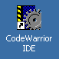
Figure 1 - CodeWarrior Launcher Icon
- Select the MCU to program and your connection to the development board. You can change your connection at any time after creating the project, for now we choose Full Chip Simulation, which allows us to just work with the IDE without a physical development board connected. We use MC9S12DP256B family of HCS12 processors. Please note DP256B is almost identical to DP512 and DG256B. Please refer to Figure 2 for details.
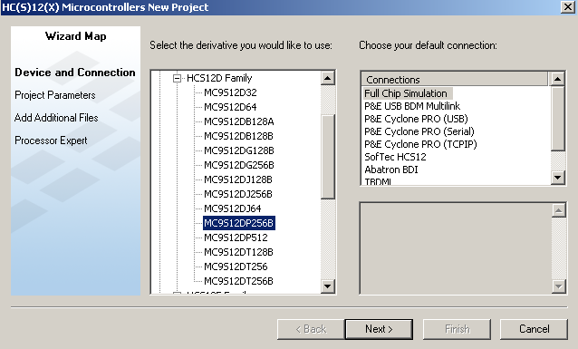
Figure 2 - MCU and Connection Method

- Set the location where the project is to be saved, and name your project. Choose the languages you will be using and click Finish. Please note you can also pre-add any files your project may use. For this lab we do not need any additional files. You can also add files to your project after it has been created. We also don’t use Rapid Application Development code generators for this lab as well.

- Refer to Figure 3 for details on how to compile, run and debug your codes.

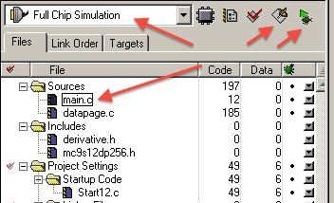
Figure 3 - Compile and Debug Icons

Lab Evaluation

- Lab demonstration to TA, in-lab explanations and answers, debug and test approach. Both students are expected to fully explain their work and codes. Weight 50%

- Program, design and document your work. Submit your report electronically within one week of the lab using the submit command on Prism systems. See the resources section of the course website for report guidelines. One report per group is required. Please ensure you identify both partners in the group clearly on the report. Weight 50%

